Python OpenCV | cv2.imread() method Library: OpenCV-Python

**OpenCV** is an open-source library of python specially designed for computer vision problems. **OpenCV-Python** is the module of **OpenCV** used for reading images**.** cv2.imread() method loads an image from the specified file/path. This method returns an empty matrix if the image cannot be read (because of the missing file, improper permissions, unsupported or invalid format) and this error type shown:

OpenCV(4.5.2) C:\Users\runneradmin\AppData\Local\Temp\pip-req-build-

_8k9tw8n\opencv\modules\highgui\src\window.cpp:404: error: (-215:Assertion failed) size.width>0 && size.height>0 in function 'cv::imshow'

**OpenCV-Python** library can be install via pip and conda;

**pip:** *pip install opencv-python*

**link:** *https://pypi.org/project/opencv-python/* **conda:** *conda install -c conda-forge opencv* **link:** *https://anaconda.org/conda-forge/opencv*

**Syntax:** cv2.imread(**str** 'Specific file path', **int** Read image - flag)

**Parameters:**

**Specific file path:** The path of an image to read as a string.

**Read image - flag**: Specifies image read in a specific way use cv2.IMREAD_COLOR.

**Value-Return:** Returns an image from the specified file.

# Example #1: Use flag by default

#OpenCV-Python

# Display an image with cv2.imread() Method/Function

# import cv2, we already install with pip/conda import cv2 as c

#where c is a reference variable of cv2

#You can set the reference variable by own just easy to use

File_path = r'C:/Users/oral_vision/Desktop/python_code/OpenCV_image.png' #used of 'r' to read the the file in specific path

image = c.imread(File_path)

#passing the path in cv2.imread() method

# c.imshow() method used for display image cv2.imshow('Displayed-image', image)

#Passing two parameter in cv2.imshow(), the file name, as you can set by own #and and read file(image)

c.waitKey(0)

**Output:**

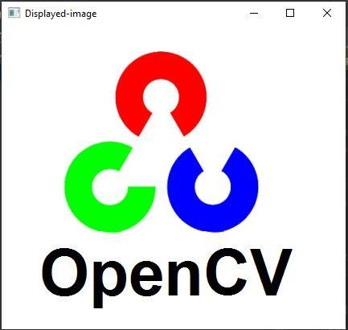

In the above example #1, first, we import the cv2 library as reference variable c; you can set the reference variable on its own, just easy to use to reduce the library word. The first thing needs to install the python-OpenCV library through the command line or with IDE. Copy the file location path and past it in quotes. On the right side, use a character r which means to read. c.imread(File_path) needs two parameters: file path and flag integer value. when you are using IDE such as pycharm or Spyder, use a method waitKey with parameter 0, show image in the screen.

**cv2.IMREAD** method has three main type of flags;

1. **cv2.IMREAD_GRAYSCALE:** Load an image from the specific path in grayscale mode. The RGB image combines three channels with different color combinations (0-256 pixels values), while the grayscale image channels are the combination of only black and white color. For a grayscale image, pass value **0** integer flag.

# Example #2: Read an image in grayscale mode

#OpenCV-Python

# Display an image with cv2.imread() Method/Function

# import cv2, we already install with pip/conda import cv2 as c

#where c is a reference variable of cv2

#You can set the reference variable by own just easy to use

File_path = r'C:/Users/oral_vision/Desktop/python_code/OpenCV_image.png' #used of 'r' to read the the file in specific path

image = c.imread(File_path,0)

#passing the path in cv2.imread() method

# c.imshow() method used for display image cv2.imshow('Displayed-image', image)

#Passing two parameter in cv2.imshow(), the file name, as you can set by own #and and read file(image)

c.waitKey(0)

# Output:

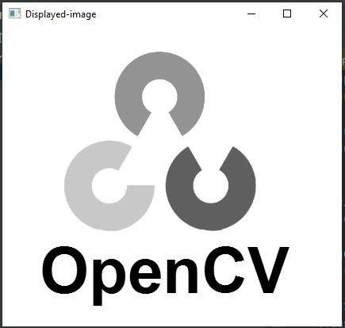

In the above example #2, firstly, we import the cv2 library as reference variable c; rest of the code you can use c instead of cv2. You can set the reference variable on its own, just easy to use to reduce the library word. Copy the file location path and past it in quotes. On the right side, use a character r which means to read.c.imread(File_path) needs two parameters: file path and a flag integer value. As differentiate from example #1, you set the flag value to 0; the method read the one channel of the file (gray image).

2. **cv2.IMREAD_COLOR:** Specifies color/RGB image to load. Pass value **1** of type integer flag.

3. **cv2.IMREAD_UNCHANGED:** Specifies alpha channel image loaded. Pass value **-1** of integer flag.

Nowadays, the bands/channels of images are increasing, i.e., spectral images having 5 or 6 bands. GIS live data applications use high-quality images. Therefore, the flag parameter of the cv2.imread() method was also upgraded day by day. The parm flag has a predefined integer value to read a specific type of image. Such as RGB, gray, Spectral, etc.

**Table 1: Imgproc class called by flag parameters**

|  |  |
| --- | --- |
| **Serial No.** | **Description** |
| **1** | **IMREAD_LOAD_GDAL:** Load an image from the specific path in spectral band  mode. For a spectral image, pass value 8 integer flag. |
| **2** | **IMREAD_ANYCOLOR**: Load an image from the specific path in any possible color  format. For a spectral image, pass value 4 integer flag. |
| **3** | **IMREAD_REDUCED_COLOR_2/IMREAD_REDUCED_COLOR_4/IMREAD_**  **REDUCED_COLOR_8:** Read RGB image reduce the image size by ½, ¼th, or ⅛th of the original size of the image concerning the field used.  IMREAD_REDUCED_COLOR_2 flag = 17, *IMREAD_REDUCED_COLOR_4* flag =  33, *IMREAD_REDUCED_COLOR_8* flag = 65 |
| **4** | **IMREAD_REDUCED_GRAYSCALE_2/IMREAD_REDUCED_GRAYSCALE_4**  **/IMREAD_REDUCED_GRAYSCALE_8:** Read image of single-channel image (grayscale) reduce the image size by ½, ¼th, or ⅛th of the original size of the image concerning the field used. IMREAD_REDUCED_GRAYSCALE_2 flag = 16, IMREAD_REDUCED_GRAYSCALE_4 flag = 32,  IMREAD_REDUCED_GRAYSCALE_8 = 64 |

**Summary**

By concluding this instructional exercise of different Python cases, we learned to utilize cv2 imread() strategy to perused an image into a Python Array, and also the way in which the image should be read. We became known that how to use Open CV library and what are the requirements of it.

**References:**

[https://docs.opencv.org/3.4/d8/d6a/group imgcodecs flags.html](https://docs.opencv.org/3.4/d8/d6a/group__imgcodecs__flags.html)

<https://www.geeksforgeeks.org/python-opencv-cv2-imread-method/>

<https://www.tutorialspoint.com/opencv/opencv_imread_xxx_flag.htm>

<https://java2blog.com/cv2-imread-python/>

<https://appdividend.com/2020/06/17/how-to-read-an-image-using-opencv-in-python/>